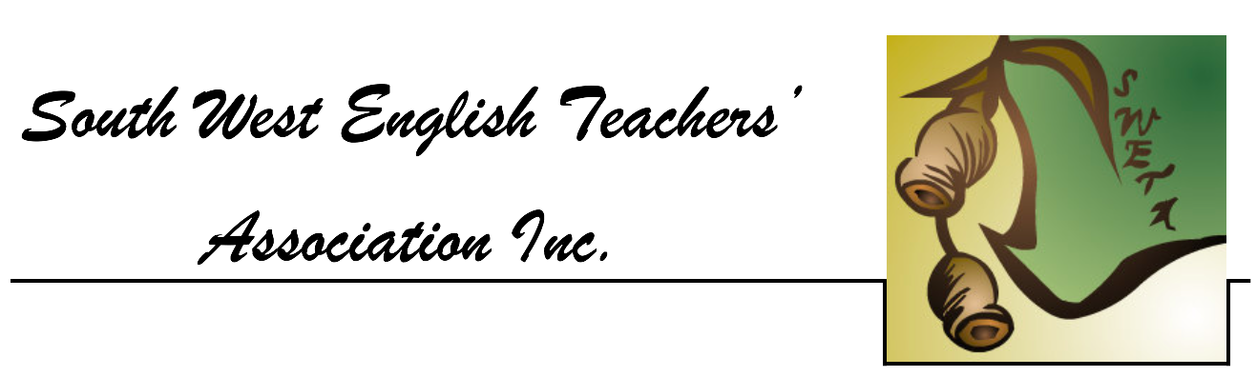

**Practice Western Australian Certificate of Education**

**ATAR course examination, 2018**

**Question/Answer booklet**

**YEAR 11**

**ATAR ENGLISH**

Place your student identification label in this box.

Student number: In figures

In words ________________________________________

________________________________________

**Time allowed for this paper**

Reading time before commencing work: ten minutes

Working time: three hours

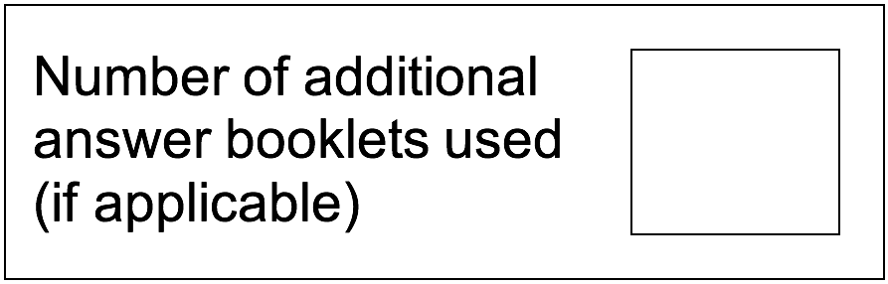**Materials required/recommended for this paper**

**To be provided by the supervisor**

This Question/Answer booklet

**To be provided by the candidate**

Standard items: pens (blue/black preferred), pencils (including coloured), sharpener, correction fluid/tape, eraser, ruler, highlighters

Special items: nil

**Important note to candidates**

No other items may be taken into the examination room. It is **your** responsibility to ensure that you do not have any unauthorised material. If you have any unauthorised material with you, hand it to the supervisor **before** reading any further.

**Structure of this paper**

|  |  |  |  |  |  |
| --- | --- | --- | --- | --- | --- |
| Section | Number of questions available | Number of questions to be answered | Suggested working time (minutes) | Marks available | Percentage of examination |
| Section One  Comprehending | 3 | 3 | 60 | 30 | 30 |
| Section Two Responding | 6 | 1 | 60 | 40 | 40 |
| Section Three Composing | 5 | 1 | 60 | 30 | 30 |
|  |  |  |  | **Total** | 100 |

**Instructions to candidates**

1. The rules for the conduct of the Western Australian Certificate of Education ATAR course examinations are detailed in the *Year 12 Information Handbook 2018.* Sitting this examination implies that you agree to abide by these rules.
2. Write your answers in the Question/Answer booklet.
3. You must be careful to confine your answers to the specific questions asked and to follow any instructions that are specific to a particular question.
4. Supplementary pages for the use of planning/continuing your answer to a question have been provided at the end of this Question/Answer booklet. If you use these pages to continue an answer, indicate at the original answer where the answer is continued, i.e. give the page number.
5. You must not use texts from Section One to answer questions from Section Two.

**Section One: Comprehending 30% (30 Marks)**

In this section, there are **three** texts and **three** questions. Answer **all** questions.

You are required to comprehend and analyse unseen written and visual texts and respond concisely in approximately 200-300 words for each question.

Suggested working time: 60 minutes.

**Question 1 (10 Marks)**

Discuss how narrative elements in Text 1 are used to convey attitude/s towards weddings and marriage.

**Question 2 (10 Marks)**

Analyse how visual and written elements in Text 2 convey values about marriage, and associate the product with these values.

**Question 3 (10 Marks)**

Explore how Texts 2 and 3 convey contrasting perspectives on diamonds and the wedding industry.

**Text 1**

*The following is an extract from the novel* This Must be the Place *by Maggie O’Farrell, published 2016.*

Severed Heads and Chemically Preserved Grouse[1]

*Todd, the Scottish Borders, 1986*

A wedding.

The bride and groom are young, newly graduated, and have the kind of open good looks that will last them a few more decades. They will be successful; they will have good-looking children; their house will have white floors, cabinets of glassware and bright toys in baskets.

Their walls will display scenes from this day: their former selves, posing beside a lake, in an artful line with their families, in the centre of their group of friends. The bride will wish, in years to come, that she hadn’t listened to her sister in the matter of eyeshadow colour. Did her sister deliberately derail her appearance on this, the most important day of her life, by suggesting the moss green, which drained all hue from her complexion? Or was it an accident?

What neither of them can know, looking at these photos of people dressed in their best, holding themselves together, presenting their faces and smiles to the camera, is how much their wedding, coming so soon after their graduation, so early in their twenties, will set ripples of paranoia and fear among their peers.

“Is this how it will be now?” the lines of younger guests in the photograph are thinking, as they smile and pose, as they hold up their champagne glasses to the camera. Are people starting to get married? Have they really reached that age? Are they to attend weddings at weekends? Is this the start of it all? A strange parade of ceremonies, rehearsal dinners, line-ups, after-parties, their friends unrecognisable in stiff, elaborate dresses and immoveable hairdos. The unfathomable lists of required items. What are fish forks and butter knives and occasional vases, and why must they buy them in exchange for attending this peculiar event?

The wedding is taking place in the borders of Scotland, a locale the majority of the guests have never visited. There is, here, a turreted, moated country house, surrounded by woods so dense and green they have a vaguely menacing fairy-tale air, crowding in where the manicured lawns of the house stop.

**Question 1 (10 Marks)**

Discuss how narrative elements in Text 1 are used to convey attitude/s towards weddings and marriage.

**This page has been left blank intentionally**

**Text 2**

*This is a re-print of a print advertisement for Tiffany’s diamond rings.*

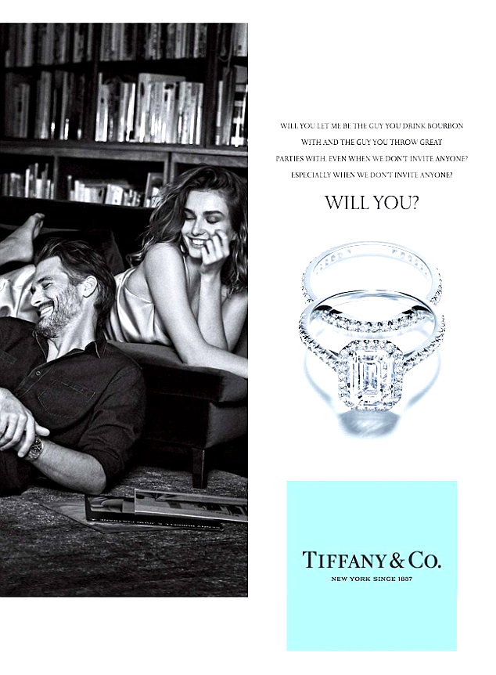

**Question 2 (10 Marks)**

Analyse how visual and written elements in Text 2 convey values about marriage, and associate the product with these values.

**This page has been left blank intentionally**

**Text 3**

*The following is an extract from an article in Time Magazine,* titled “Blood Diamonds” *written by Aryn Baker, published August 27, 2015.*

Max Rodriguez knows exactly how he is going to propose marriage to his long-term boyfriend, Michael Loper. He has booked a romantic bed-and-­breakfast. He has found, using Google Earth, a secluded garden where he plans to take Loper for a sunset walk. The only thing that troubles him is the ring. Rodriguez has heard about how diamonds fuel distant conflicts, about the miserable conditions of the miners who wrest the stones from the earth, and he worries. “I don’t want a symbol of our union to also be associated with chaos and controversy and pain,” says Rodriguez.  
  
To Mbuyi Mwanza, a 15-year-old who spends his days shovelling and sifting gravel in small artisanal[2] mines in southwest Democratic Republic of Congo, diamonds symbolize something much more immediate: the opportunity to eat. Mining work is gruelling, and he is plagued by backaches, but that is nothing compared with the pain of seeing his family go hungry. His father is blind; his mother abandoned them several years ago. It’s been three months since Mwanza last found a diamond, and his debts—for food, for medicine for his father—are piling up. A large stone, maybe a carat, could earn him $100, he says, enough to let him dream about going back to school, after dropping out at 12 to go to the mines—the only work available in his small village. He knows of at least a dozen other boys from his community who have been forced to work in the mines to survive.

Mwanza and Rodriguez are on opposite ends of an $81.4 billion-a-year industry that links the mines of Africa, home to 65% of the world’s diamonds, with the sparkling salesrooms of high-end jewellery retailers around the world. Given the ugly realities of the diamond business, it would be tempting to forgo buying a diamond altogether. But diamonds are a vital source of ­income for an estimated 1 million small-scale, or artisanal, miners in Congo who dig by hand for the crystals that will one day adorn the engagement ring of a bride-or groom-to-be. “If people stop buying our diamonds, we won’t be able to eat,” says Mwanza. “We still won’t be able to go to school. How does that help us?”

**Question 3 (10 Marks)**

Explore how Texts 2 and 3 convey contrasting perspectives on diamonds and the wedding industry.

**End of Section One**

**This page has been left blank intentionally**

**Section Two: Responding 40% (40 Marks)**

In this section, there are **six** questions. Answer **one** question.

Your response should demonstrate your analytical and critical thinking skills with reference to any text or text type you have studied.

Suggested working time: 60 minutes.

**Question 4 (40 Marks)**

Explain how structure, language features an/or other stylistic choices were used effectively in **one** or more texts studied.

**Question 5 (40 Marks)**

Explore how film conventions are used to affect the response of the viewer in at least **one** text studied.

**Question 6 (40 Marks)**

“Texts allow us to experience different perspectives on the world.”

Discuss with reference to at least **one** text studied.

**Question 7 (40 Marks)**

With reference to at least **one** text studied, discuss the impact of context on the purpose of that text.

**Question 8 (40 Marks)**

Discuss your response to a main character in at least **one** text studied, exploring how that character’s values are conveyed to the audience.

**Question 9 (40 Marks)**

Some texts call their audience to action by encouraging exploration of imagined futures they would or would not want to live in.

Discuss with reference to at least **one** text studied.

Question number: **________________**

**End of Section Two**

**Section Three: Composing 30% (30 Marks)**

In this section, there are **five** questions. Answer **one** question.

You are required to demonstrate writing skills by choosing a form of writing appropriate to a specific audience, context and purpose.

Suggested working time: 60 minutes.

**Question 10 (30 Marks)**

Write a narrative text in which the concept of hunger is explored.

**Question 11 (30 Marks)**

“One man practicing sportsmanship is far better than fifty [preaching it](http://www.anvari.org/fortune/Miscellaneous_Collections/196105_one-man-practicing-sportsmanship-is-far-better-than-50-preaching-it-knute-rockne.html).” (Knute Rockney)

Respond to this idea, in a form of your choice.

**Question 12 (30 Marks)**

Using the image below as inspiration, write either a narrative or persuasive text.



**Question 13 (30 Marks)**

“If I had to live my life again, I’d make the same mistakes, only sooner”. (Tallulah Bankhead).

Write a narrative text which incorporates this quote.

**Question 14 (30 Marks)**

Respond to the image below in a form of your choice.

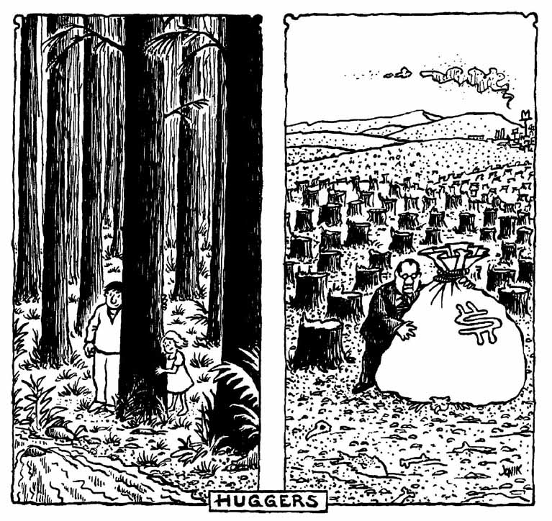

**End of questions**

Question number: **________________**

Additional working space

Question number: **________________**

Additional working space

Question number: **________________**

Additional working space

Question number: **________________**

**ACKNOWLEDGEMENTS**

**Text 1** O’Farrell, M., (2016), *This must be the Place,* Tinder Press: UK

**Text 2** Retrieved August 2018 from

http://conversationsabouther.net/ August

**Text 3** Baker, A., (2015), “Blood Diamonds”, *Time Magazine*, 27th August 2015

Copyright **©** South West English Teachers’ Association 2018.

1. Grouse: a short, fat bird hunted for sport and food,
2. Artisanal: traditional, non-mechanised